NETWORK TRAFFIC ANALYSIS REPORT
CONFIDENTIAL & RESTRICTED
1. DOCUMENT CONTROL & METADATA
Document Title | Wireshark Network Traffic Analysis Report
Target Scope | Local Host Network Interface (Ethernet/Wi-Fi)
Assessor Name | Abhinav Dey
Date of Assessment | July 7, 2026
Assessment Tooling | Wireshark Network Protocol Analyzer
2. EXECUTIVE SUMMARY
This report documents the active network traffic capture and protocol analysis conducted on the local host machine. The primary objective of this exercise was to capture live network packets, apply display filters, and analyze fundamental network protocols including DNS, TCP, TLS, and ARP.
The methodology relied on installing Wireshark and the Npcap driver, initializing a capture on the active interface, and generating specific web requests. The capture successfully demonstrates the mechanics of the TCP Three-Way Handshake, the encryption standards of Transport Layer Security (TLS), and the encapsulation process of the OSI and TCP/IP models.
3. PRE-ENGAGEMENT: INSTALLATION & INITIALIZATION
3.1 Objective
To securely download and install the Wireshark application along with the necessary Npcap packet capture driver, and initialize a live packet capture on the local network interface.
3.2 Installation Process
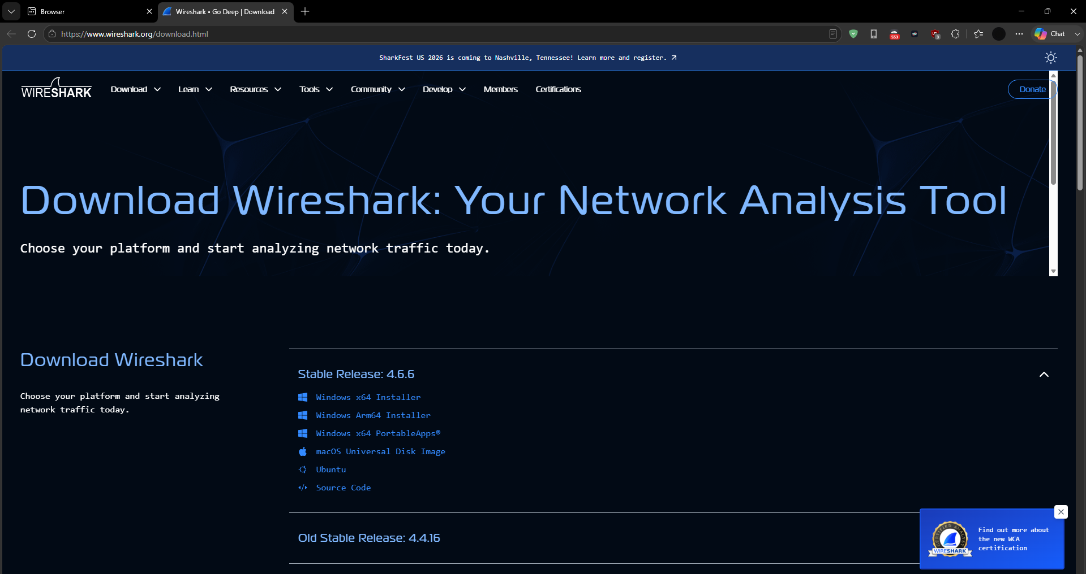

The Wireshark installer was securely downloaded from the official repository.
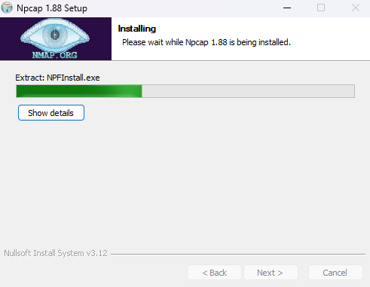

During the installation process, the Npcap driver was successfully deployed. Npcap is critically required for intercepting raw packets on Windows interfaces.
3.3 Interface Selection & Live Capture
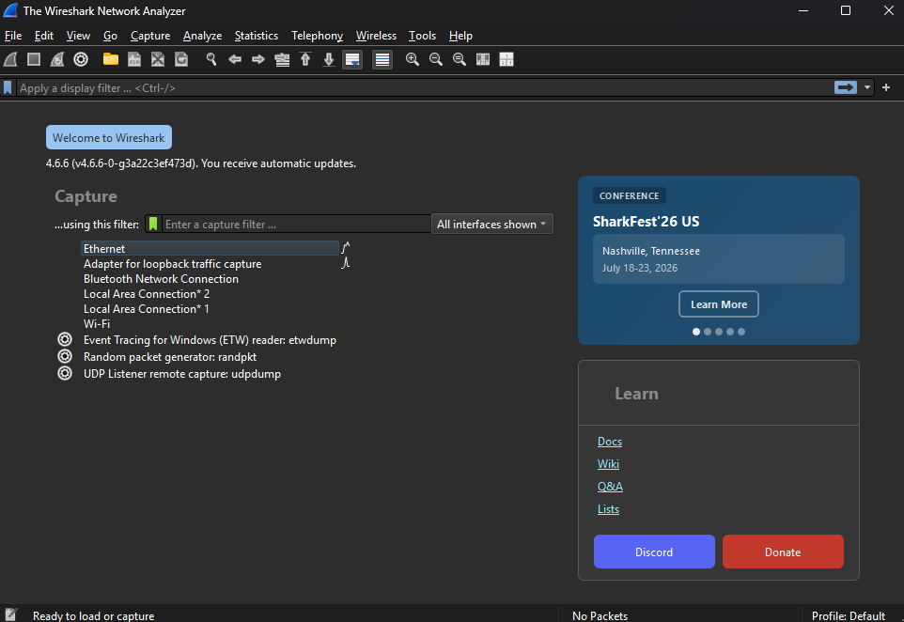

Upon launching the application, the available network interfaces were analyzed. The active interface showing active traffic metrics was selected for capturing.
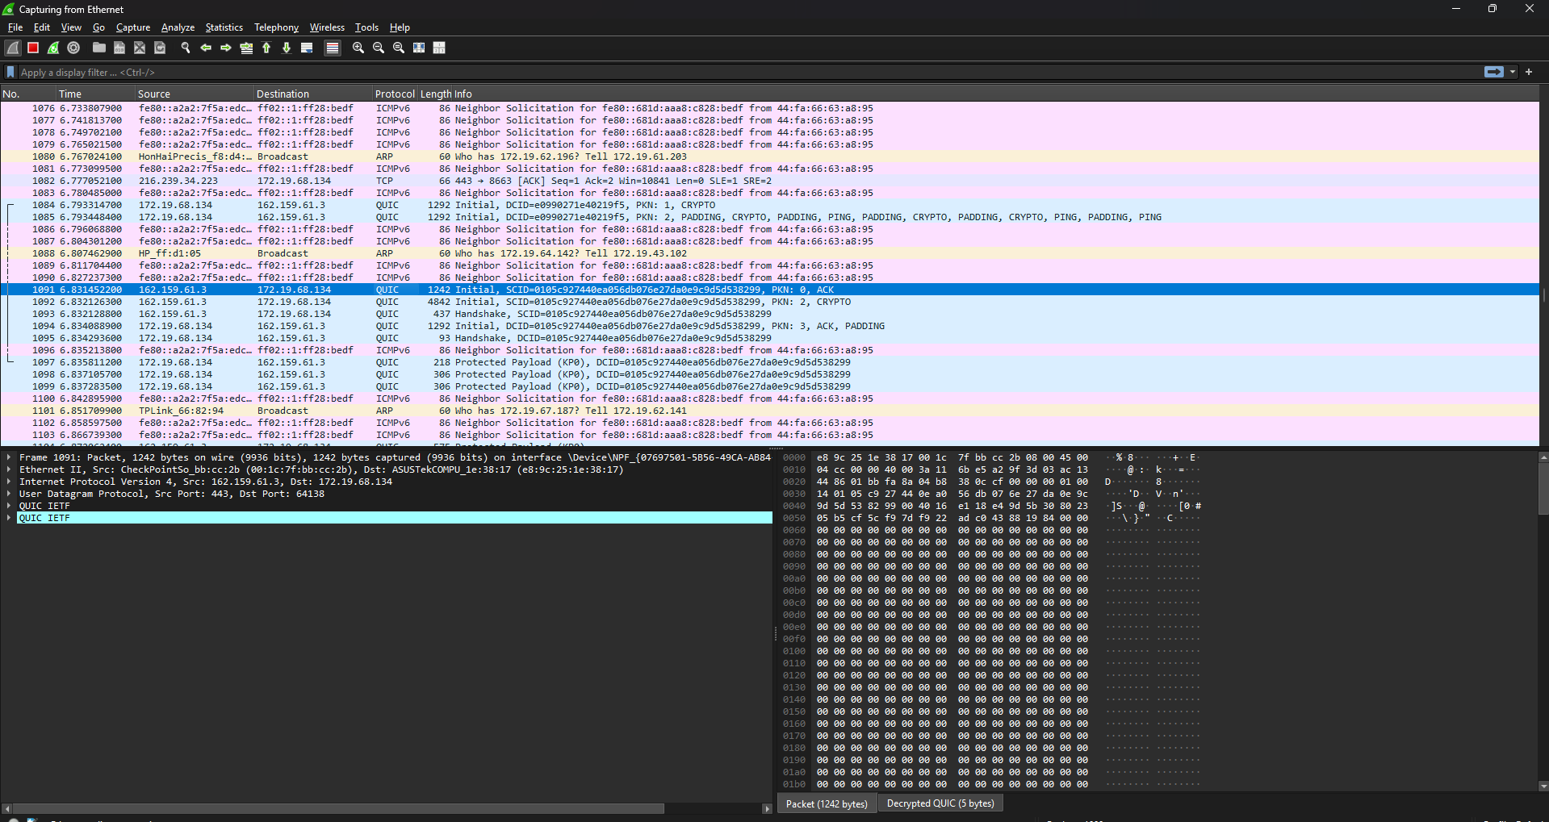

Figure 4. Live network traffic capture using Wireshark over the Ethernet interface.
The capture was successfully initialized, immediately revealing transit protocols such as TCP, TLS, UDP, and ARP, verifying that the Npcap driver was functioning correctly.
4. ACTIVITY 1: DNS PROTOCOL ANALYSIS
4.1 Objective
To filter and analyze a Domain Name System (DNS) query and its corresponding response to understand how domain names are resolved into IP addresses.
4.2 Methodology & Filter Executed
Traffic was generated by navigating to various web domains. The capture was then isolated using the following Wireshark display filter: dns
4.3 Analysis & Findings
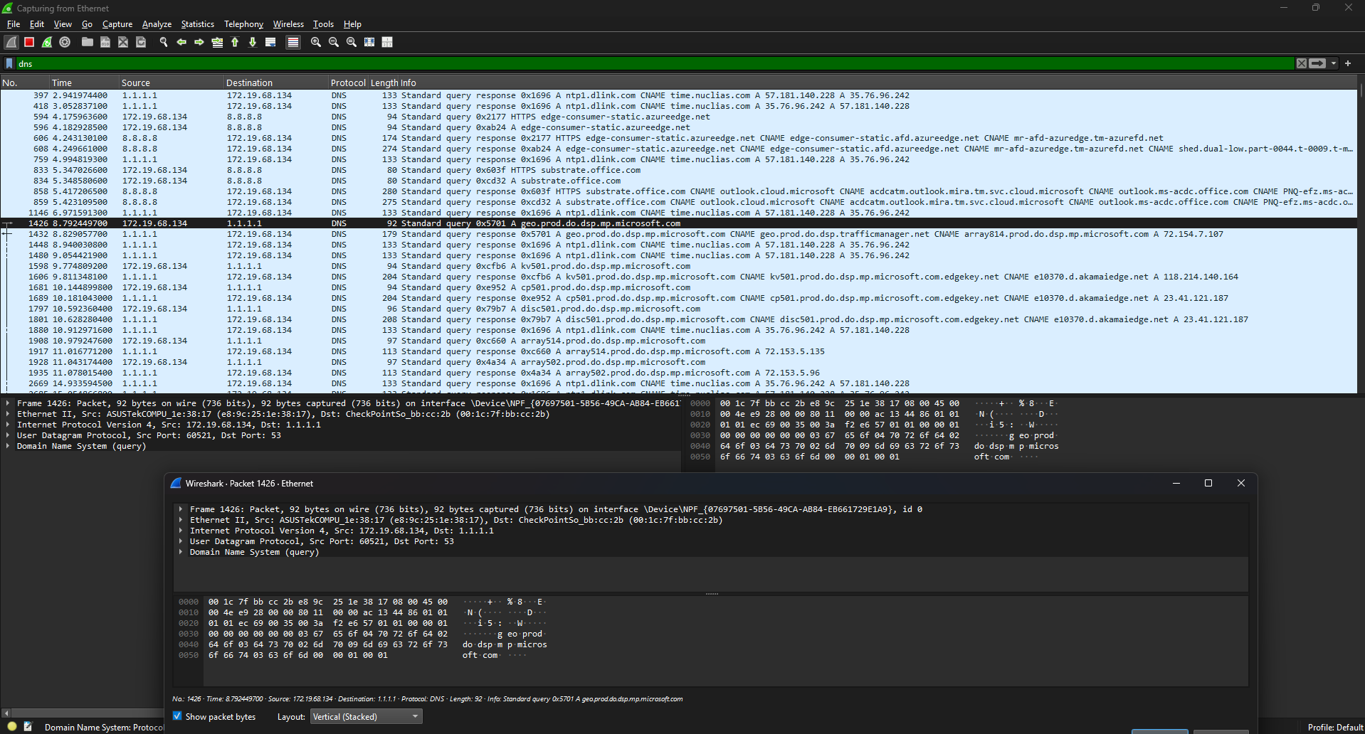

• The Query: The local machine sent a "Standard query" to the DNS Server (1.1.1.1 - Cloudflare), asking to resolve a Microsoft domain name into an IP address.
• The Response: The DNS server replied with a "Standard query response," providing the translated IP address so the local machine knew exactly where to route the traffic.
5. ACTIVITY 2: TCP CONNECTION ESTABLISHMENT
5.1 Objective
To analyze the Transmission Control Protocol (TCP) and specifically capture the Three-Way Handshake used to establish reliable connections.
5.2 Methodology & Filter Executed
The capture was isolated to show only TCP SYN packets to identify the beginning of new connections. Filter used: tcp.flags.syn==1
5.3 Analysis & Findings
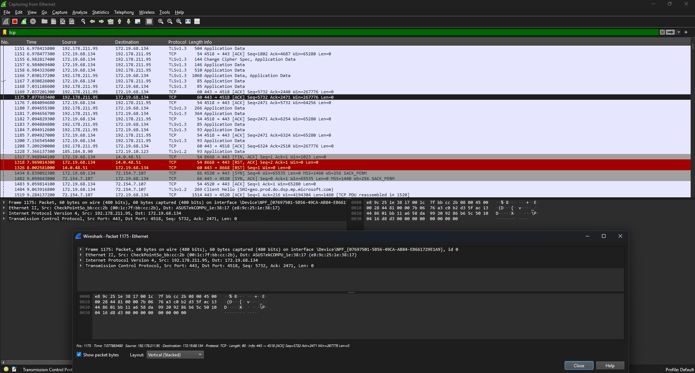
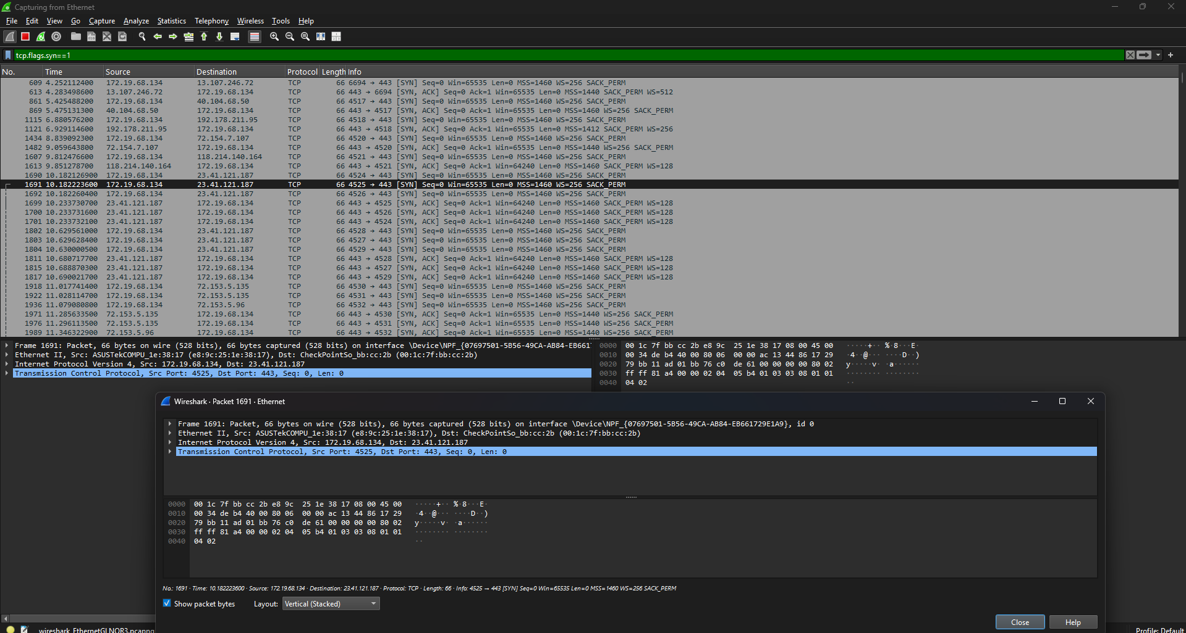

The capture successfully demonstrates the three phases of connection establishment:
1. [SYN]: The client machine initiates the connection.
2. [SYN, ACK]: The server acknowledges the request and agrees to connect.
3. [ACK]: The client acknowledges the server, and data transmission begins.
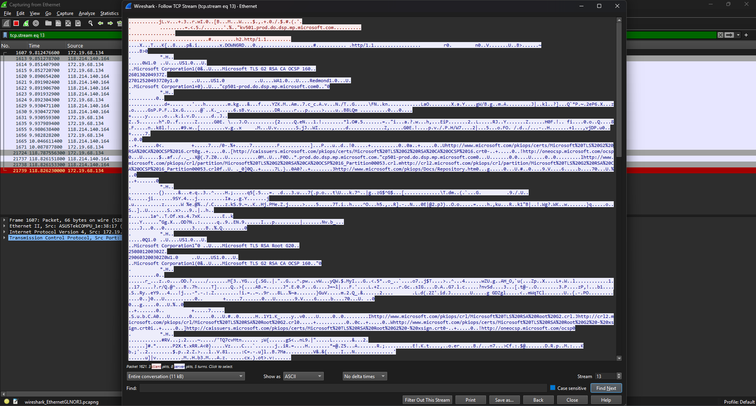

By following the TCP Stream, the raw conversation payload between the client and server was observed.
6. ACTIVITY 3: TLS ENCRYPTION ANALYSIS
6.1 Objective
To identify Transport Layer Security (TLS) traffic and observe how encrypted web traffic (HTTPS) is handled on the network.
6.2 Methodology & Filter Executed
The display filter tls was applied to isolate encrypted web traffic.
6.3 Analysis & Findings
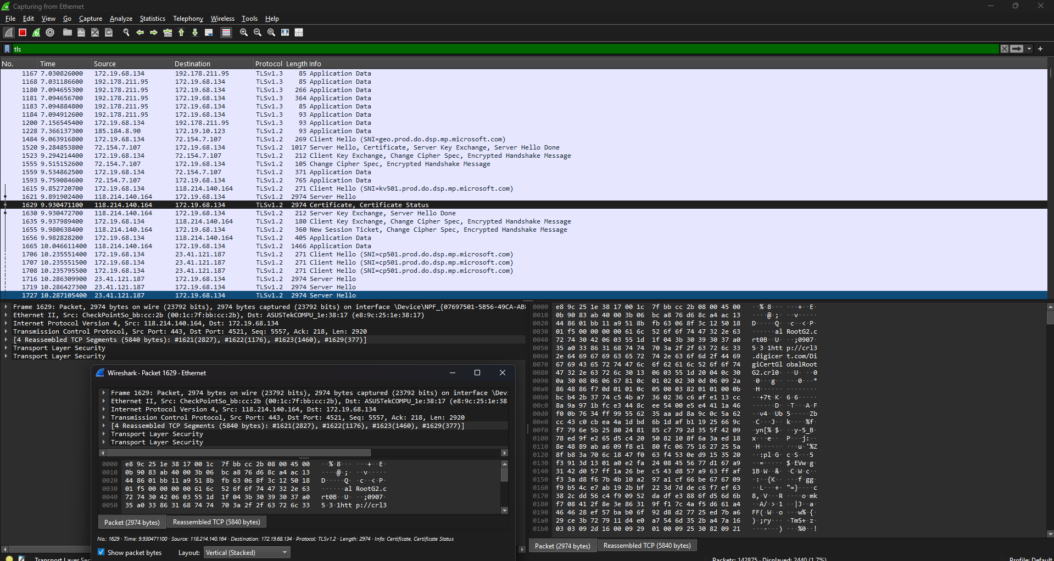

The packet capture revealed extensive TLSv1.2 and TLSv1.3 traffic. While the raw application data (the payload) is scrambled and unreadable due to encryption, the initial Client Hello, Server Hello, and Certificate exchanges are visible, proving that the session is secured.
7. ACTIVITY 4: ARP RESOLUTION
7.1 Objective
To capture Address Resolution Protocol (ARP) broadcasts and understand MAC address discovery on a local subnet.
7.2 Methodology & Filter Executed
The display filter arp was applied to isolate local hardware resolution requests.
7.3 Analysis & Findings
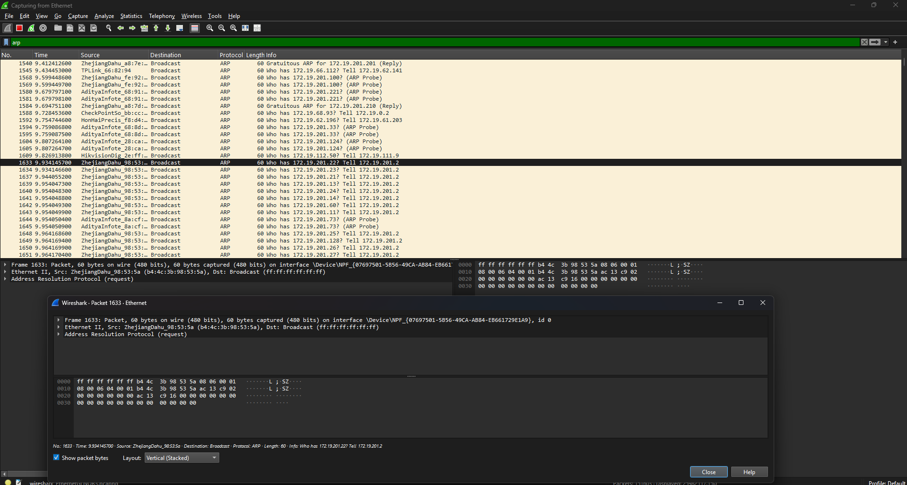

The capture revealed local network broadcast requests (e.g., "Who has [IP]? Tell [IP]"). Furthermore, Wireshark successfully translated the MAC Address OUI (Organizationally Unique Identifier) into the hardware manufacturer's name (Zhejiang Dahua), demonstrating the presence of specific IoT hardware on the local subnet.
8. ACTIVITY 5: OSI LAYER ENCAPSULATION
8.1 Objective
To expand and inspect the encapsulation of a network packet to demonstrate the layers of the OSI/TCP-IP model.
8.2 Analysis & Findings
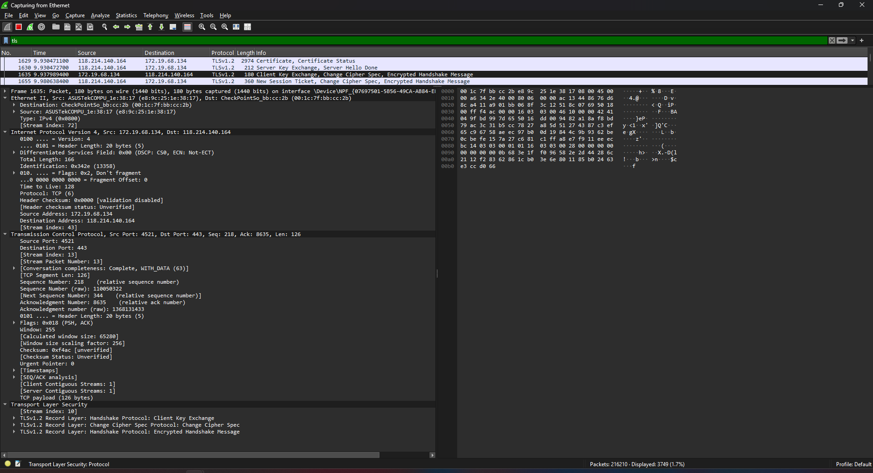

By selecting a single TLS packet and expanding the details pane, the strict, mathematical encapsulation of network traffic was observed:
• Layer 2 (Data Link): Ethernet II
• Layer 3 (Network): Internet Protocol Version 4 (IPv4)
• Layer 4 (Transport): Transmission Control Protocol (TCP)
• Layer 7 (Application): Transport Layer Security (TLS)
9. CONCLUSION
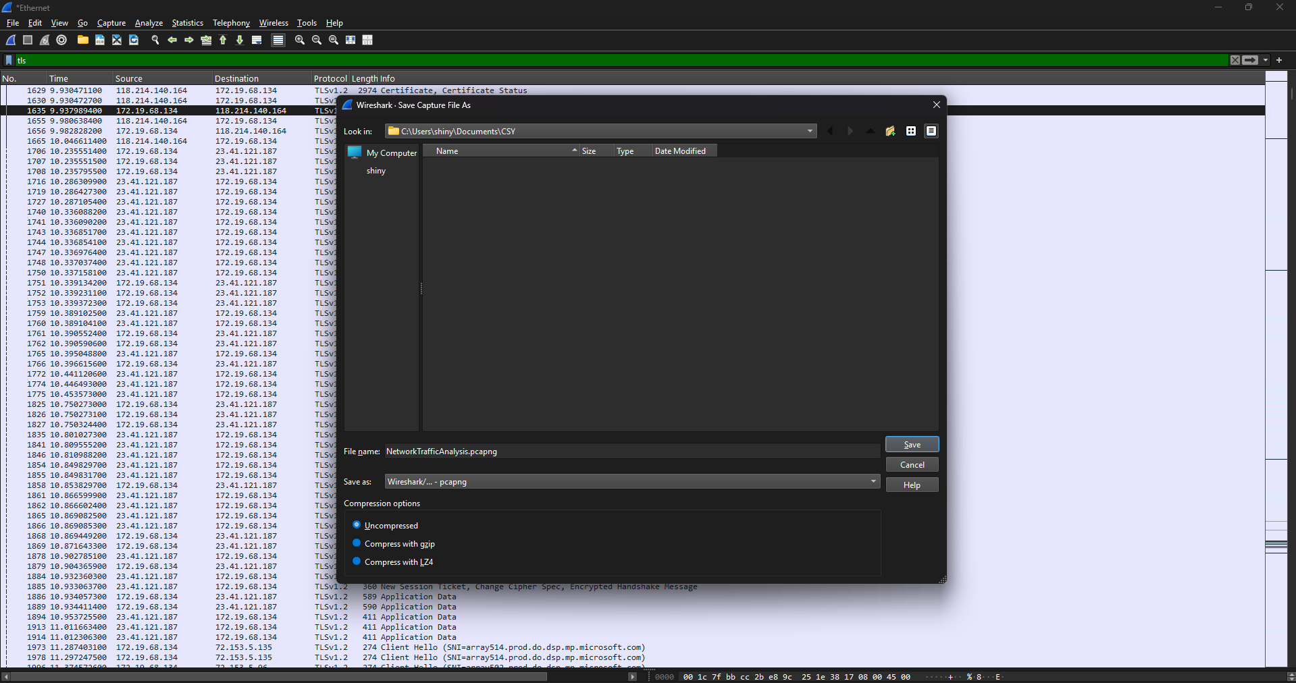

The capture was successfully halted and the raw packet data was exported and saved as NetworkTrafficAnalysis.pcapng for future forensic review. All laboratory objectives regarding protocol analysis, OSI layer identification, and environment initialization were met.

